

RoundTable - License File Generator
Brian Abbott, December 23rd, 2004

Dommoni Corporation – Internal Documentation

Introduction
The License File Generator is a centrally managed tool to generate license files for RoundTable Collaboration Environment. This guide will take you through using it from installation, standard usage, and removal.

Note: This is an internal guide and the LFG is an internal tool. Neither items should be distributed or made available to anyone outside of the company.

Installation
The LFG uses and runs with the Microsoft .NET framework. This guide assumes you already have the .NET Framework installed and running on your computer.

Once you have the RoundTable LFG Installation Executable and are ready to begin the installation process, begin by clicking on the executable. You should then see the following screen appear.

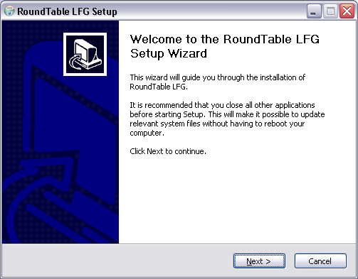

Accept the default settings and continue clicking next. You should receive a message informing that the installation was completed successfully. Press the close button on the installer and the License File Generator should be ready to run!

Application Guide

Assuming your local installation occurred without any problems, you should now have a new folder in your Windows Start Menu titled “RoundTable LFG”. There are two items available within the folder.

